Частное образовательное учреждение
“Средняя общеобразовательная школа Лицей Магистр”
Реферат по английскому языку
“Capital of Culture”
Работу подготовила:
Ученица 7 класса
Кузнецова Дарья
Проверила:
Учитель английского языка
Клиновицкая Н.В.
Орёл 2021

The Capital of Culture
The topic of my project is «The Capital of Culture».
The content:
1) Introduction (some words about the Capitals of Culture) …………………………………………3
2) The main body:
a) The history of the capitals ………………………………………………………………………….….………….4
b) What are the Russian capitals of Culture?......................................................................11
c) Can my town become the capital of Culture?................................................................12
3)Conclusion……………………………………………………………………………………………………………..….13

Introduction.
The capital of Culture is an initiative of the European community. Every year people choose one or some cities to get attention for its cultural progress. The city has to have an interesting history and a rich culture. The Capital of Culture gets special finance to develop its culture further. Using special finance people in Capitals of Culture build new museums, make festivals, fairs, concerts, restore old buildings. Guests of this cities can visit some museums, squares, zoos, nature reserves, shopping and leisure centres. The Council of the European Union chooses Capitals of Culture for some next years: for example, we can know what cities will be Capitals of Culture in 2025.
The aim of this project is to tell you about the Capital of Culture, its history, and what cities were, are and will become Capitals of Culture. Also I would like to tell you, what does your town need to become a Capital of Culture.
The aim of the Capitals of Culture is keeping cultural ties between European nations and supporting for local creative industries.
In the end of the 20th century two projects like European Capitals of Culture started – “American Capital of Culture” and “Arab Capital of Culture”. In 21st century one more similar project started - “The Capital of Culture of the Turkic world”.
It’s hard to become the Capital of Culture. The city has to take part in a competition. Also it has to submit an application 6 years before voting.
Candidates have to:
- Have a cultural development strategy;
- Have a lot of people who’re interested in city becoming the Capital of Culture. Usually the city uses supporting from schools, universities and youth clubs.
Then during the year candidates are selected in two stages. Cities, which overcame the first stage, get ready for second selection. If they overcame the second stage, the governments of their countries appoint the cities as the Capitals of Culture and announces it 4 years in advance.

The history of the capitals.
The European Capitals of Culture
The idea of the project “Capital of Culture” belonged to Melina Mercouri, Greece’s Minister of Culture, and her French counterpart Jack Lang. In 1985, at a session of the Council of Ministers of the European Union, they decided that European citizens need to know more about their culture and share it with their neighbours.
The first European Capital of Culture was Athens (the Capital of Greece) in 1985.
First time only 1 city in a year could become a Capital of Culture. But since 2000 more cities can become a capital of Culture. For example, in 2000 9 cities became capitals of Culture, in 2010 3 cities, in 2020 2 cities.
But in 2020 coronavirus came to the Europe. A lot of countries had to close their state borders. That’s why Capitals of Culture 2020 - Rijeka (Croatia) and Galway (Ireland) could be Capitals of Culture till April 2021.
In 2022 3 cities will become Capitals of Culture – Kaunas (Lithuania), Esch-sur-Alzette (Luxembourg) and Novi Sad (Serbia).
The list of cities, which became the Capitals of Culture, you can see on page 6.
American Capitals of Culture
American Capitals of Culture was founded in 1998. The aim of this project was to raise awareness of culture in the Americas and to promote the city selected as the Capital of Culture for the year. The chosen city is publicized on the television networks Antena 3 and the Discovery network. The first capital of Culture in America was Mérida from Mexico. It became a Capital of Culture in 2000. In America only 1 City in year can become a Capital of Culture. But in 2003 2 cities became Capitals of Culture: Panama City from Panama and Curitiba from Brazil.
The list of cities, which became the Capitals of Culture, you can see on page 5.

The history of the capitals.
The Arab Capitals of Culture
The project Arab Capitals of Culture is an initiative taken by the Arab League under the UNESCO Cultural Capitals Program. The aim of this project was to promote and celebrate Arab culture and encourage cooperation in the Arab region. The first capital of Culture in Arabia was Cairo from Egypt. It became a Capital of Culture in 1996. In Arabia only 1 City in year can become a Capital of Culture.
The list of cities, which became the Capitals of Culture, you can see on page 9.

The Capitals of Culture of the Turkic world
Culture and Arts Capital of the Turkic World is a city designated by the TÜRKSOY for a period of one calendar year during which it organises a series of cultural events.
The decision for a cultural capital was made during the tenth meeting of Türksoy in 2010. The first city is selected as Astana for the year 2012. The first Capital of Culture in the Turkic world was Astana from Kazakhstan. It became a Capital of Culture in 2012.
The list of cities, which became the Capitals of Culture, you can see on page 6.

American Capitals of Culture
Year | City | Country
2000 | Mérida | Mexico
2001 | Iquique | Chile
2002 | Maceió | Brazil
2003 | Panama City | Panama
 | Curitiba | Brazil
2004 | Santiago | Chile
2005 | Guadalajara | Mexico
2006 | Cordoba | Argentina
2007 | Cuzco | Peru
2008 | Brasília | Brazil
2009 | Asunción | Paraguay
2010 | Santo Domingo | Dominican Republic
2011 | Quito | Ecuador
2012 | São Luís | Brazil
2013 | Barranquilla | Colombia
2014 | Colima | Mexico
2015 | Mayagüez | Puerto Rico
2016 | Valdivia | Chile
2017 | Mérida | Mexico
2018 | Anzoátegui | Venezuela
2019 | San Miguel de Allende | Mexico
2020 | Punta Arenas | Chile
2021 | Estado de Zacatecas | Mexico

European Capitals of Culture
Year | City | Country
1985 | Athens | Greece
1986 | Florence | Italy
1987 | Amsterdam | Netherlands
1988 | West Berlin | West Berlin
1989 | Paris | France
1990 | Glasgow | United Kingdom
1991 | Dublin | Ireland
1992 | Madrid | Spain
1993 | Antwerp | Belgium
1994 | Lisbon | Portugal
1995 | Luxembourg City | Luxembourg
1996 | Copenhagen | Denmark
1997 | Thessaloniki | Greece
1998 | Stockholm | Sweden
1999 | Weimar | Germany
2000 | Avignon | France
2000 | Bergen | Norway
2000 | Bologna | Italy
2000 | Brussels | Belgium
2000 | Helsinki | Finland
2000 | Kraków | Poland
2000 | Prague | Czech Republic
2000 | Reykjavík | Iceland
2000 | Santiago de Compostela | Spain
2001 | Rotterdam | Netherlands
2001 | Porto | Portugal
2002 | Bruges | Belgium
2002 | Salamanca | Spain
2003 | Graz | Austria
2004 | Genoa | Italy
2004 | Lille | France
2005 | Cork | Ireland
2006 | Patras | Greece
2007 | Sibiu | Romania
2007 | Luxembourg City | Luxembourg
2008 | Liverpool | United Kingdom
2008 | Stavanger | Norway
2009 | Vilnius | Lithuania
2009 | Linz | Austria
2010 | Essen | Germany
2010 | Istanbul | Turkey
2010 | Pécs | Hungary
2011 | Turku | Finland
2011 | Tallinn | Estonia
2012 | Guimarães | Portugal
2012 | Maribor | Slovenia
2013 | Marseille | France
2013 | Košice | Slovakia
2014 | Riga | Latvia
2014 | Umeå | Sweden
2015 | Mons | Belgium
2015 | Plzeň | Czech Republic
2016 | San Sebastián | Spain
2016 | Wrocław | Poland
2017 | Aarhus | Denmark
2017 | Paphos | Cyprus
2018 | Leeuwarden | Netherlands
2018 | Valletta | Malta
2019 | Matera | Italy
2019 | Plovdiv | Bulgaria
2020-April 2021 | Rijeka | Croatia
2020-April 2021 | Galway | Ireland
2022 | Kaunas | Lithuania
2022 | Esch-sur-Alzette | Luxembourg
2022 | Novi Sad | Serbia
2024 | Tartu | Estonia
2024 | Bad Ischl | Austria
2024 | Bodø | Norway
2025 | Nova Gorica | Slovenia
2025 | Chemnitz | Germany
Capitals of Culture of the Turkic world
Year | City | Country/Region
2012 | Astana | Kazakhstan
2013 | Eskişehir | Turkey
2014 | Kazan | Tatarstan ( Russia)
2015 | Mary | Turkmenistan
2016 | Sheki | Azerbaijan
2017 | Turkistan | Kazakhstan
2018 | Kastamonu | Turkey
2019 | Osh | Kyrgyzstan
2020 | Khiva | Uzbekistan
Arab Capitals of Culture
Year | City | Country
1996 | Cairo | Egypt
1997 | Tunis | Tunisia
1998 | Sharjah | United Arab Emirates
1999 | Beirut | Lebanon
2000 | Riyadh | Saudi Arabia
2001 | Kuwait City | Kuwait
2002 | Amman | Jordan
2003 | Rabat | Morocco
2004 | Sana'a | Yemen
2005 | Khartoum | Sudan
2006 | Muscat | Oman
2007 | Algiers | Algeria
2008 | Damascus | Syria
2009 | al-Quds | State of Palestine
2010 | Doha | Qatar
2011 | Sirte | Libya
2012 | Manama | Bahrain
2013 | Baghdad | Iraq
2014 | Tripoli | Libya
2015 | Constantine | Algeria
2016 | Sfax | Tunisia
2017 | Luxor | Egypt
2018 | Oujda | Morocco
2019 | Port Sudan | Sudan
2020 | Bethlehem | State of Palestine
2021 | Irbid | Jordan
2022 | Kuwait City | Kuwait
2023 | Tripoli | Lebanon

What are Russian Capitals of Culture
There is a Capital of Culture in Russia. It is a city with a rich culture and history, this city was built as a capital of Russian Empire. This city is Saint Petersburg.
Saint Petersburg is a very important city. Peter the 1st founded this city in 1703. Saint Petersburg was the Capital of Russia. That’s why now people in Russia call it “The North Capital of Russia”. Saint Petersburg changed its name for 3 times.
Saint Petersburg is a very cool city. It has won 3 World Travel Awards in the category "Leading Cultural Destination"! St. Petersburg has a very rich culture. It has a lot of different palaces, parks, leisure centres and squares.
Saint Petersburg is a very beautiful city. You can see nice view of Neva. In winter Neva has an ice on its surface, so people can walk there, but you should be careful on ice. Near Neva there are different people in costumes and fancy dresses. You can take photo with them, but these photos aren’t free. If you visit St. Petersburg, you must visit the park “Field of Mars”. It’s really beautiful!
Now 5 388 759 people live in St. Petersburg. Millions visitors all around the world go to this city every year. Every part of Saint Petersburg has its own history.
There are a lot of cities in Russia. Every city has its own history and culture. Some other cities in Russia can become Capitals of Culture.
The city which can become the Capital of Culture is Sochi. This city is important for Russia. A lot of big competitions are there. This city has a very rich culture! Also nature beauty and fantastic views are thrilling!

Can my town become a Capital of Culture?
My town is Oryol. It isn’t very big and isn’t very small.
Oryol is a historical town. Ivan IV founded it in 1566. A lot of poets and writers were born or lived in Oryol. In the Great Patriotic war fascists occupied the city
during two years. When Oryol became free, in this town was made the first firework since the beginning of the war. That’s why now people call Oryol “The Town of the first fireworks”.
Oryol is a very beautiful town. The architect of the main buildings is beautiful! The nature beauty in parks and squares is wonderful! Oryol was the host town of many concerts.
Oryol has a lot of schools, universities and kindergardens.
People call Oryol the “Literature Capital of Culture”. But this town isn’t a Capital of Culture of Russia.
Oryol isn’t a very big town. Only 308838 people live in Oryol right now.
Oryol is very beautiful, but very dirty polluted town. Here you can see a lot of rubbish.
I think Oryol can’t be the Capital of Culture. Oryol’s Cultural progress isn’t so good. Maybe after fifty years Oryol will change.
Our town needs a lot of changes to be a Capital of Culture. The first is to have more attractions. The second is to work with the view of our town.

Conclusion
So, I have completed the project tasks. I told you information about the Capitals of Culture.
There are five projects called “Capital of Culture”. The first project was “The European Capitals of Culture”. In my opinion it is the most important project from all.
I did a survey among my classmates. I asked them: “Can our town become a Capital of Culture?” Most of them said me “No”. Only two people said that our town can become the Capital of Culture.
I did an interview with Alice. I asked her: “Can our town become the Capital of Culture?” She answered me:
- Not really. In my humble opinion our town isn’t a town that has a lot of attractions like another cities like Suzdal or Saint Petersburg. Maybe one day it will become, but not now.
The Alice’s reason why our town can’t become the Capital of Culture is the same that my classmates’ reason. All they think that there isn’t so many attractions that Capitals of Culture need. Some of them think that the view of our town isn’t so good.
All cities are good. Any town which is interested in its cultural development has a chance to be the Capital of Culture.
In my opinion the idea of the project “ Capital of Culture” is very good and interesting. Cities with awesome culture and history have a year to shine! This project is good for visitors, inhabitants and us.

Photos
- Athens
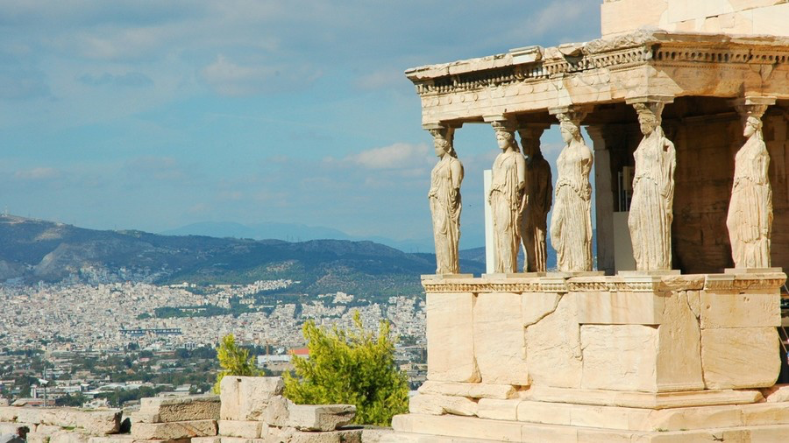
- Melina Mercouri
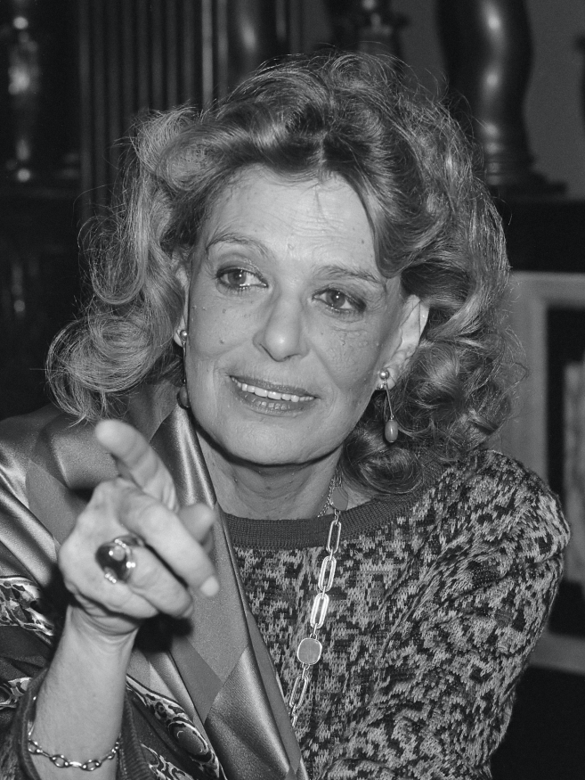

- Saint Petersburg

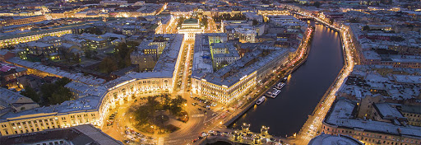
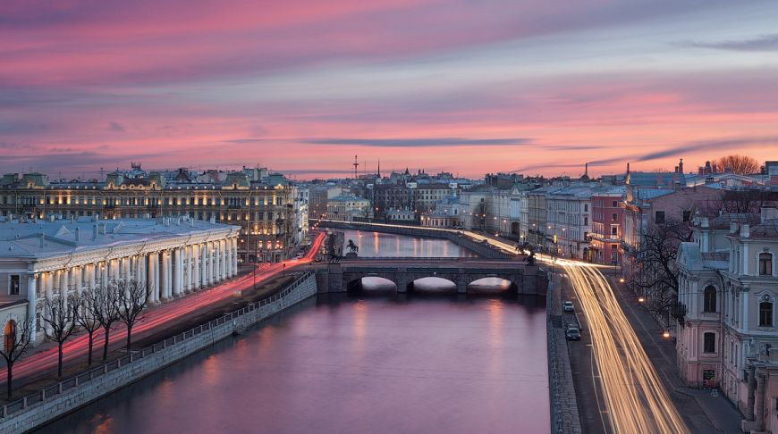

- Oryol
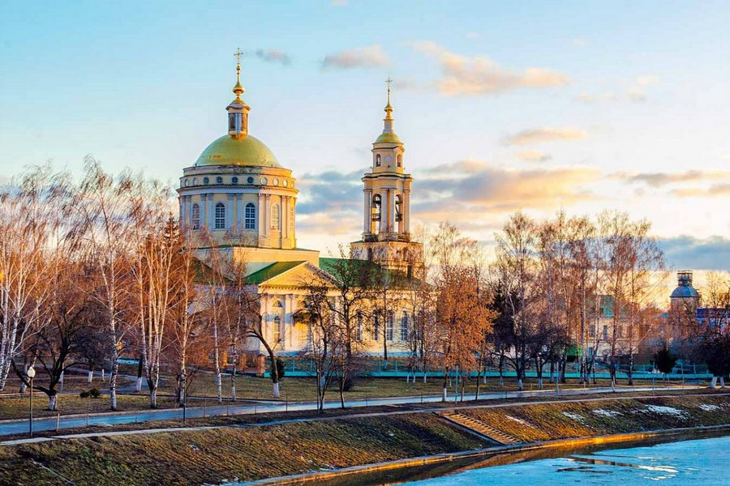
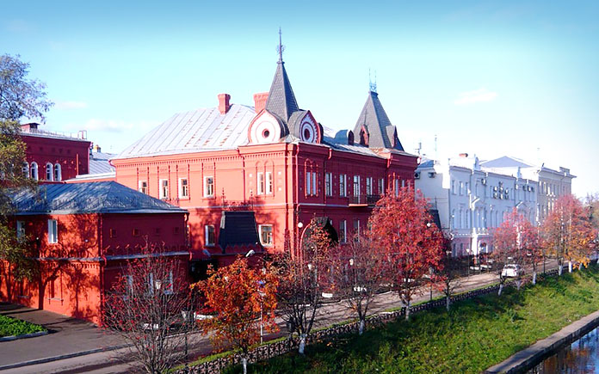

- Sochi
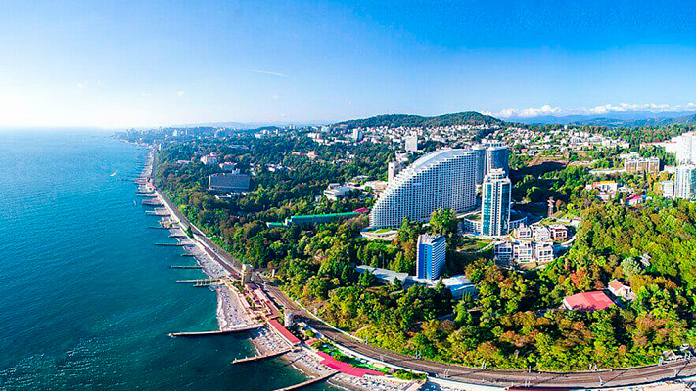
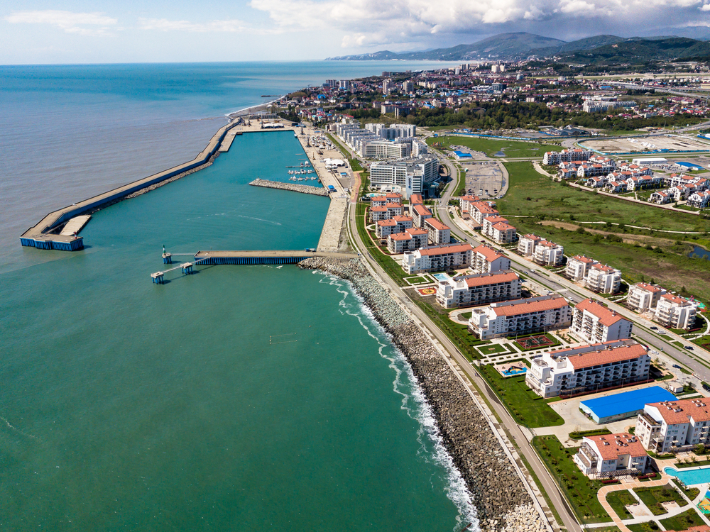

List of used websites
- https://en.wikipedia.org/wiki/European_Capital_of_Culture
- https://en.wikipedia.org/wiki/American_Capital_of_Culture
- https://en.wikipedia.org/wiki/Arab_Capital_of_Culture
- https://zen.yandex.ru/media/rusbeyond/pochemu-imenno-piter-stal-kulturnoi-stolicei-rossii-5d77b3b13f548700ad8b856a
- https://www.google.ru/imghp?hl=ru

