Content
Introduction…………………………………………………………………………………………………………………2

History of museum’s creation………………………………………………………………………………………3

History of Adzhimushkayskay quarries’ defense………………………………………………………….5

Attachment…………………………………………………………………………………………………………………..8

List of used sources………………………………………………………………………………………………………16

Introduction
Cultural heritage is an important part of every nation’s life. Heritage sites save and pass values to next generations, store information about development and formation of the modern society. Moreover, cultural heritage is significant to every single person as personality formation is impossible without knowing traditions and experience of the ancestors. Saving such kind of sites is an important task for any generation. This provides an opportunity for spiritual growth and development of the whole mankind.
There are 23 sites of cultural and natural legacy in Russia which are included in UNESCO list. In our country not only historic and cultural monuments and natural complexes are under state security but unique and invaluable natural and cultural landscapes. However, majority of them are not familiar even to residents of our country.
The aim of this project is to raise awareness of one of the heroic but unknown pages of the history of our country during the Great Patriotic War and to make this page a part of lyceum seminars and wanderings. Russia has lots of monuments connected with this war. Some of them are modest and unsightly while others are known outside our country. I’m willing to tell about the object of Russian nations’ cultural heritage of federal significance which is not well known among Russians. I came across it when I was on holiday in Crimea. This place is Adzhimushkayskie quarries.
Adzhumushkay is a settlement in 5 kilometers from Kerch where Big and Small Adzhimushkayskie quarries are situated. Quarries are artificial cages which are a result of a shell rock mining and look like long underground labyrinths.
During the Great Patriotic war, the Adzhimushkay quarries became the base of the partisan movement. The legendary heroism was performed by underground garrison of soldiers of these quarries. In May 1942 the Nazis, having superiority in military equipment, especially in aviation, broke through the defense of the troops of the Crimean front and our soldiers were forced to retreat. In the Adzhimushkay area fierce battles took place in 14 and 15 may 1942.
Adzhumushkay defense lasted for five and a half months (from May 16 to October 31, 1942) and entered the chronicle of the Great Patriotic war as one of the most heroic and at the same time tragic page. Later Soviet people called legendary Adzhimushkay as Kerch Brest and the unconquered fortress on the Crimean land in honor of its immortal feat.

History of museum’s creation
Today there is a memorial museum in the stone quarries of Adzhimushkay. The entrance is marked by two huge pylons, where the figures of soldiers and civilians are frozen in stone. In the early postwar decades, the defense of the Adzhimushkay did not receive adequate publicity, but in the mid-1960s government decided to take the quarry under protection as a place of military glory.
Search expeditions began here in the 1960s. They were led by the students of Kerch school № 17, who managed to make a number of significant findings in a few years. A museum dedicated to this tragic page in the history of the Great Patriotic war and the hero city Kerch was opened in 1966. Initially the exhibition consisted of a part of the tunnels, in which the atmosphere of that period was reproduced with the participation of the survived defenders of Adzhimushkay.
The most numerous search expedition took place in the summer of 1973. The biggest part of work was done by the veterans of the defense. One of the most significant findings were 2 half-burnt gas smoke bombs and the corpus of a smoke or chemical grenade which collapsed into fragments. Members of the expedition claimed that the Nazis had used suffocating toxic substances which were blown with smoke for which they made such smoke bombs, but objective evidence could not be found.
A memorial to the heroes of the Adzhimushkay quarries was opened in 1982. This memorial complex includes the museum of the history of defense of Adzhimushkay quarries (underground exhibition) and exhibitions in pylons.
In 2008 the exposition of the underground museum was renewed. Currently, the following exposures are offered to visitors:
- not previously published documents of the Crimean front;
-personal belongings of the defenders found during the excavations;
- water pump — rebuilt underground well;
- field hospital and surgery room;
- mass graves of fighters;
- gas shelters;
- children's burial — separate room with soft toys;
- pits and rubbles —bombs were dropped through them into the catacombs;
- barracks — places for soldiers to relax;
- kitchen which supplied provision to the entire population of tunnels;
- tractor — it was used in the first days as a power generator;
- command headquarters.
At the end of the hour tour a minute of silence is announced, the light goes out, and the ringing silence and pitch darkness makes everyone think about something important…
After the entry of Crimea into the Russian Federation, the reserve is financed by the ministry of culture of Crimea Republic. For 2019 from the budget of Crimea Republic will provide a subsidy of 77 033 577 rubles. The ministry of defense of Russia directs the Memory Watch search expeditions, its financing comes from the presidential grants fund. Members of the search movements and search battalions of the Russian defense ministry come to take part in the expedition including the Orel regional public organization "Military-historical search club "Battalion". Their goal is to establish the names, search for the fallen soldiers in the defense of the Motherland. During the Memory Watch of 2017 participants found 66 remains of soviet soldiers, 3 medallions. One medallion was readable and the name of the soldier was identified. The found soldier, Philip Sevastyanovich Glebkin, was a native of Oryol region who had been considered as missing. The last letter to his family came from him in 1941. Later, after the eternity of nescience, searchers found his alive relatives. The remains of the soldier were reburied with full honor.
Our lyceum can visit the memorial complex "Adzhimushkay" within the four-year program of wanderings not only to get acquainted with the history of Crimean Peninsula during the Great Patriotic war but also to learn the names of our countrymen-orlovtsev who fought there. As part of the Memory Watch, students and teachers of "Magister" can take part in the search work as our lyceum has already had such experience.

History of Adzhimushkayskay quarries’ defense

Adzhimushkay is a pain of Kerch and at the same time a symbol of unprecedented courage of the soviet people during the Great Patriotic war. The Nazis tried to seize the Kerch twice. In 1941, the red Army forces managed to push the enemy back, and in 1942 the city was eventually occupied.
When it became clear that to continue the defense is impossible due to the superior forces of the enemy and the lack of weapons and ammunition, the command of the Crimean front considered that the only way was to evacuate troops and civilians on the territory of Taman Peninsula. During the evacuation more than 120 thousand people were transported. Troops covering the retreat had to remain until the further notice. However, it had never come true. Nearby Adzhimushkay territory was surrounded by the Germans, so soviet troops decided to go down to the underground catacombs and to continue struggling against the Nazi invaders.
By that time consolidated squads consisted of more than 10 thousand people. In addition, about 7 – 8 thousand local residents went under the ground with the Red army (the elderly, women and children mainly). From that time difficult days of the defense began. Despite unbearable conditions (darkness and cold -the temperature was not higher than 12 degrees) quarry defenders were not just waiting for reinforcements but also made daring attacks not to give a chance to relax to the enemy and to distract enemy’s forces on themselves.
The soldiers of the underground garrison had to prepare for a long defense and solve a number of specific problems, because there were no supplies of water, food, medicines, weapons, ammunition and anything else which was necessary for life and struggle.
Lighting problem
The first problem which immediately arose was the problem of lighting. Garrison used makeshifts such as flares which were mainly made from rubber tires. In addition, there was a lot of telephone cable in the catacombs, it was pulled along the corridors at the height of the lowered hand so that a person could move without light, holding this wire.
Water supply problem
The problem of water supply was also acute. There were a few places where the liquid was dropping from the ceiling. There was put guard, the collected water was distributed to the wounded and sick. At the same time, water was sucked from the damp walls and ceiling. Here a small hole was made and a rubber tube was fixed in it. A person was forcefully sucking air through a tube and a small mouthful of water appeared. It was an excruciating job. During the extraction of water people had to stand for hours in an unnatural position, mouth and lips were swollen.
The construction of underground wells could have solved the problem of water supply. The work was extremely hard, the stone had to be hammered by hand. The only well, which they managed to dig, was a depth of 14.5 meters. Water is still there.

Food problem
Food problem in the beginning of the defense was not serious. In the Central quarries before the encirclement were situated warehouses of Kerch military forces. N. D. Nemtsov in the memoirs reports that at the very beginning of fights for Adzhimushkay he and his companions had enough food supplies. Someone brought two boxes of cognac from the warehouse one of them was consumed before the fight, but after the gas attack all were put on hard rations: bread — 200 gr., fat — 10 gr., concentrates — 15 gr., sugar — 100 gr. on one person. Such tiny ration did not exist in any other part of our army. Big amount of sugar draws attention. The Central quarries had significant reserves of sugar. Not did its norm decrease but it increased. This is confirmed by the participants themselves. For example, E. F. Valko says: "In the end sugar was the main food, and only because of it we survived. I was so tired of eating sugar that after the war I could not eat it for several years."
By the end of the resistance defenders started to eat rats that bred out of nearby corpses. People tried to cut the rats head and feet, because they could contain ptomaine. Some quarry defenders admitted that eating rats saved them from starvation.
Organization of medical service
According to the words of several members of the defense, in the first days the medical service was organized because there appeared a lot of the wounded under the ground and the number of them increased every day.
In the coldest place of the quarries, where the temperature did not rise above +6 degrees Celsius, underground hospital was located at a depth of 16 meters. The ceiling above the operating table was padded with a cloth to prevent stone chips from falling into the wounds during the operation. There were not enough elementary medicines, there were no anesthetics, so all operations were carried out without anesthesia. At the same time, almost all of them were successful.
Lack of weapons and ammunition
There was a catastrophic lack of weapons and ammunition, weapons were repaired underground. According to D. P. Vlasov, "... first of all automatic weapons were repaired, i.e. machine guns –one gun was created from 2 or 3 others, and the shooting was already held on the Krauts…»
For the speedy suppression of partisans in the underground tunnels of the Adzhimushkay quarry suffocating gas was used for several times. The description of one of such terrible days remained in the diary of Sarikov-Trofimenko which was found in quarries in 1944. He wrote: "...my chest is so compressed that there is nothing to breathe. I hear a scream, a noise, I grab quickly, but it is too late... I Feel like I'm suffocating, I lose consciousness, I fall to the ground, someone picks me up and drags to the exit. Come to myself. They give me a gas mask. Now I have to rescue the wounded that are in the hospital... Screaming, rending groans, these who can – walk, who can’t – creep, who falls out of bed and just moan: "Help, dear friends! I'm dying! …»
Only at the end of October 1942 the invaders managed to occupy the underground fortress and capture those who remained alive. After a year, in November 1943, Soviet troops liberated Kerch.
The statistics about Adzhimushkay feat:
- 170 days lasted the siege of quarries;
- 13 000 soldiers and commanders of the red army were cut off from the main forces of the USSR;
- 48 fighters were found in the catacombs alive by the Nazis;
- 23 people voluntarily surrendered;
- less than 10 red army soldiers got out of the Adzhimushkay encirclement and successfully crossed the front line.

Attachment

Memorial to the heroes of Adzhimushkay quarries
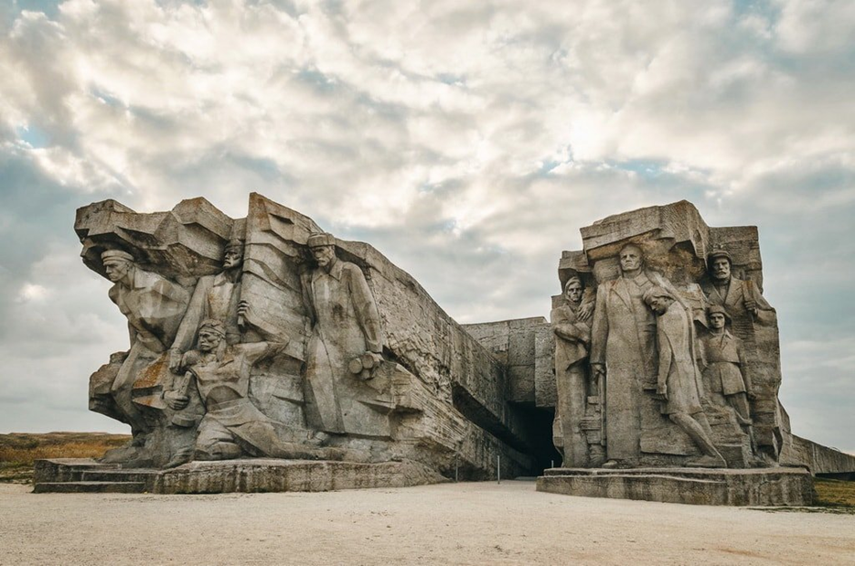

Excursions in the quarries

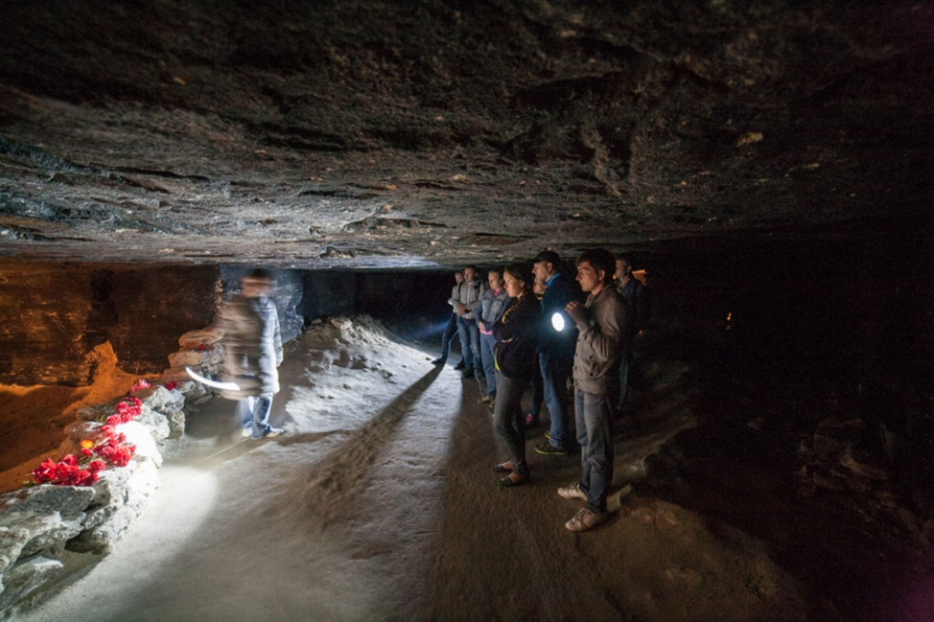
Watch 2018. Participants and their finding – car engine

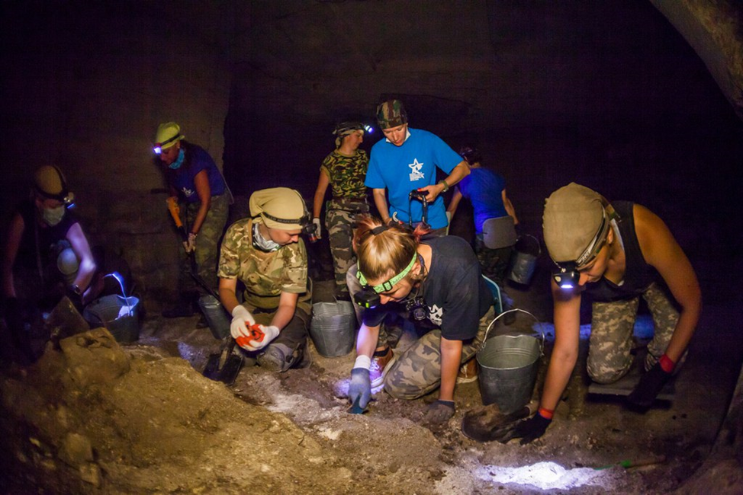

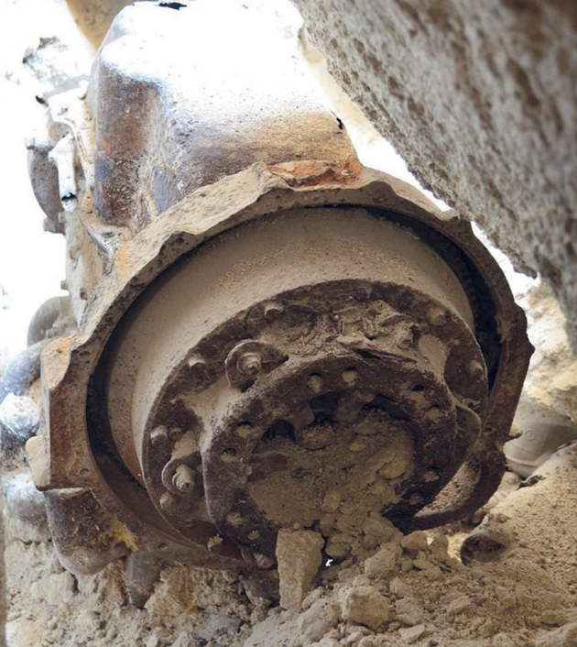
Personal belongings of the defenders of quarries

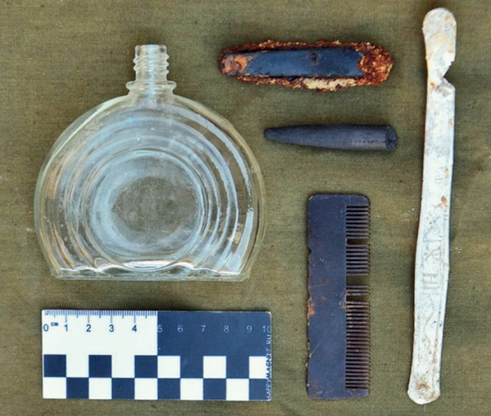

Field hospital and operating room

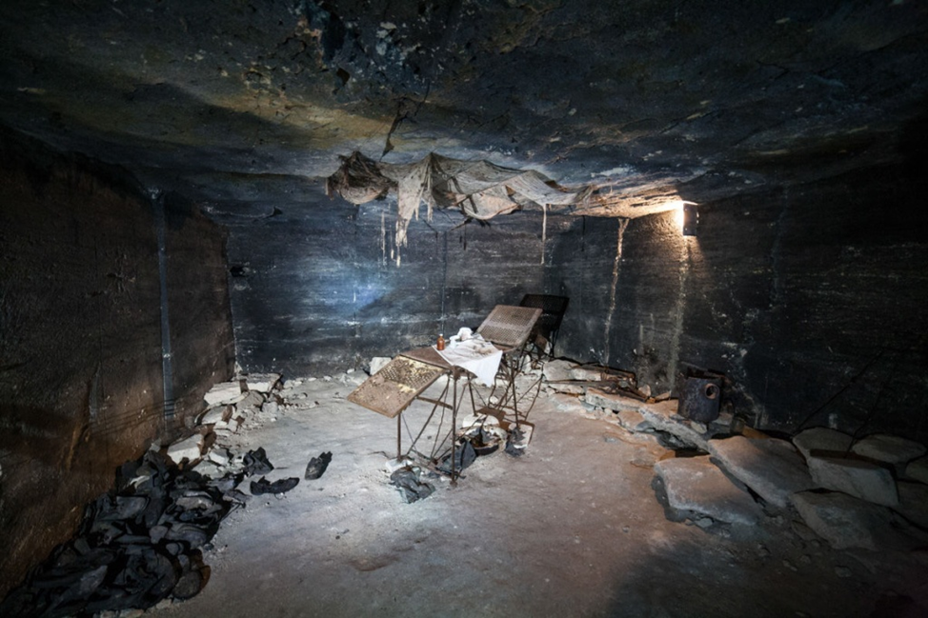
Water pump and the underground well

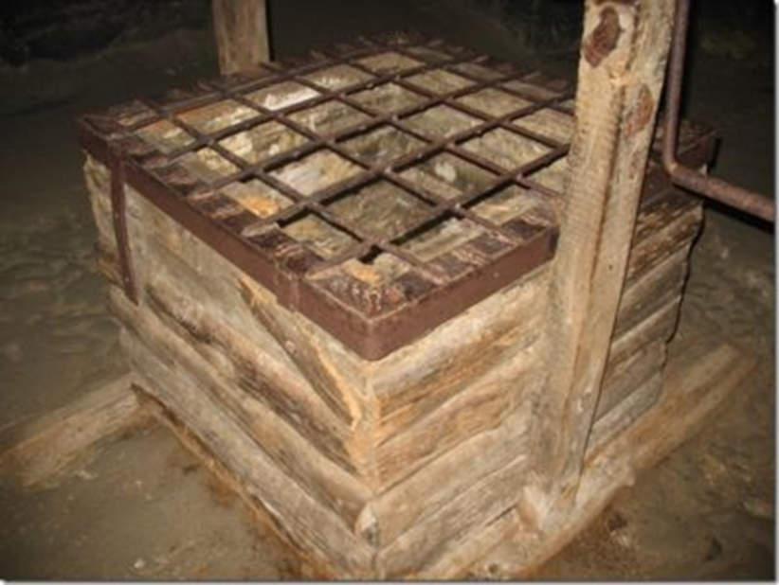

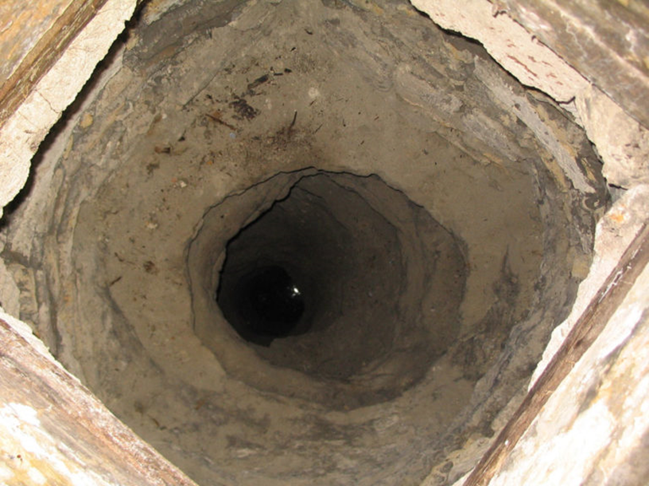

Mass graves of fighters

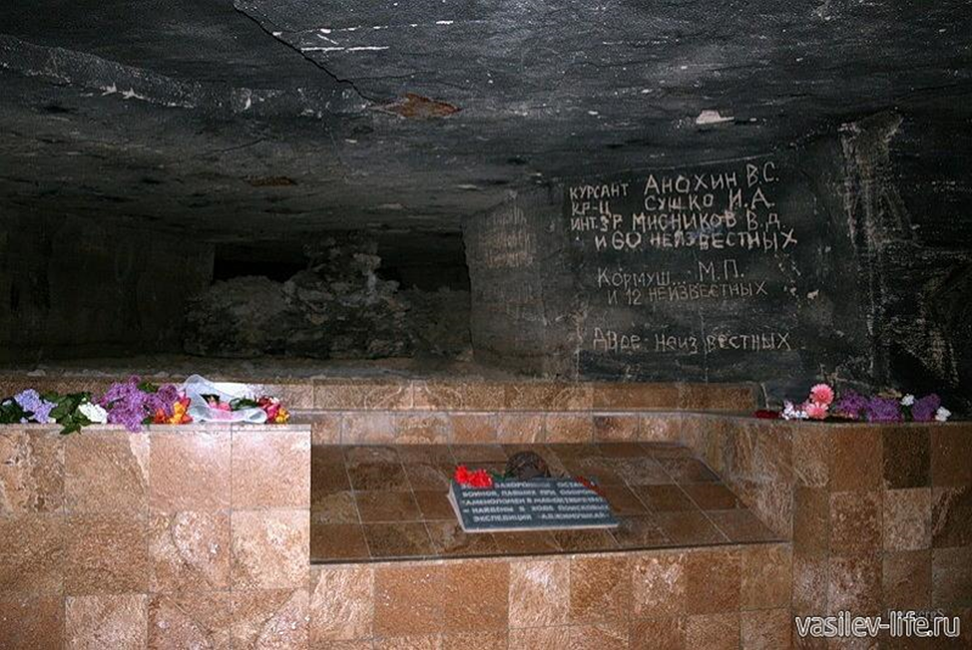

Gas shelters

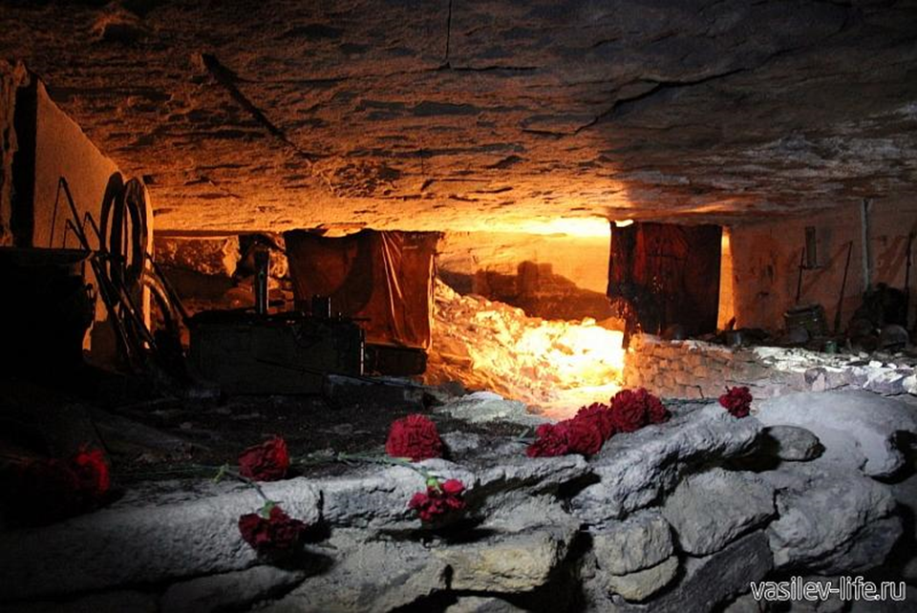
Children's burial

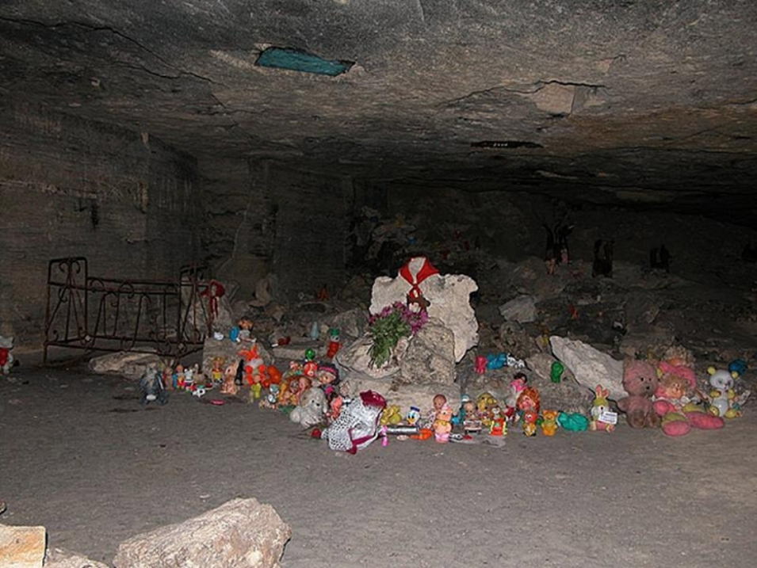

Pits and rubble —bombs were dropped through them in the catacombs

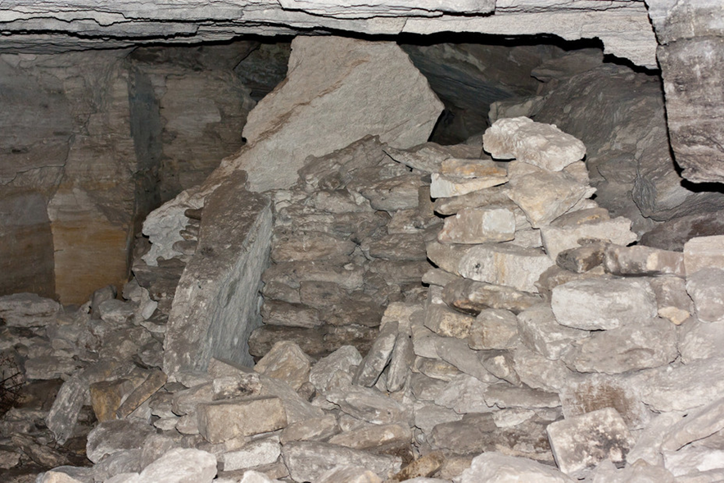
Barracks — places for soldiers to relax

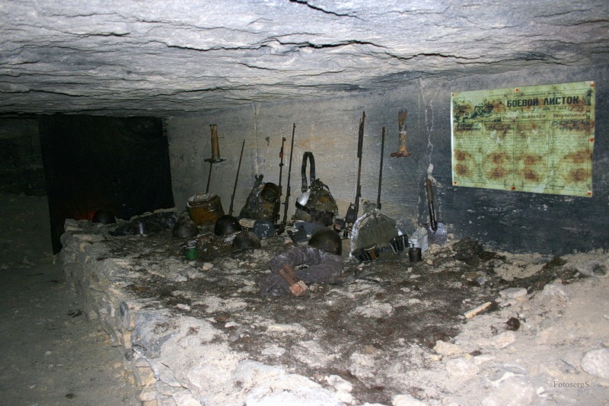

Kitchen which supplied provision to the entire population of tunnels

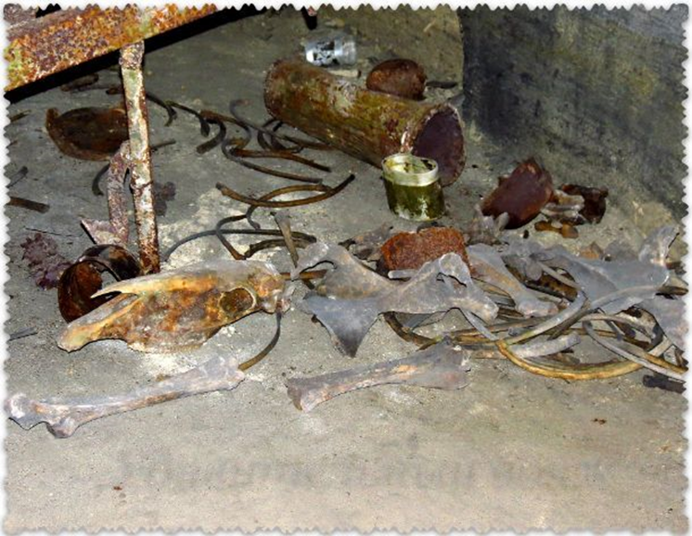

Command headquarters

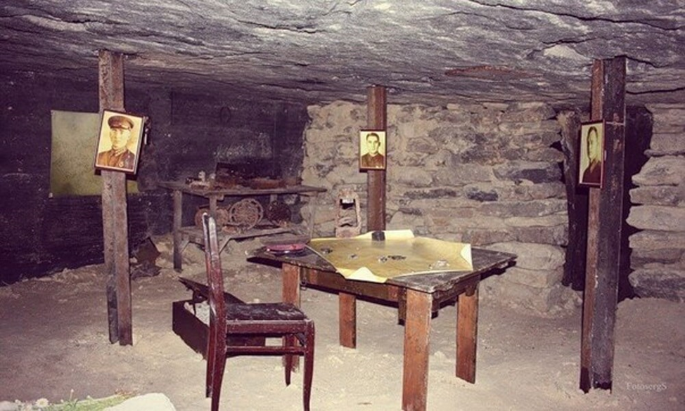

List of used sources

1. Abakshin E. History of the underground garrison from the last participant of the
defense of Adzhimushkay
http://nowcrimea.ru/articles/nebanalnyy-krym/podzemnaya-krepost-adzhimushkaya/
2. Abramov V.V. Kerch catastrophe 1942. http://militera.lib.ru/h/abramov_vv/16.html
3. Adzhimushkay tragedy. The battle for the Crimea 1941-1944 (from defeat to
triumph) https://military.wikireading.ru/18917
4. Diary of senior lieutenant A.I. Klabukov
https://poisk-ru.ru/s10724t10.html
5. Kolibukov N. Adzhimushkay, M, 1975.
https://poisk-ru.ru/s10724t10.html
6. Memory... The underground citadel — Adzhimushkay quarry https://ftkimmeriya.ru/pamyat-podzemnaya-tsitadel-adzhimushkayskie-kamenolomni/
7. Nekrasov V. The commander of the small Adzhimushkay quarries
https://www.proza.ru/2015/12/19/2188
8. Notes from the quarry defenders' diaries
http://left.ru/2003/13/patrioty89.html
9. Official site of the East Crimean Historical and Cultural Museum-Reserve.
http://kerchmuseum.ru/ru/otchetnost.html
10. Runov V.A. Battle for Crimea 1941-1944.
https://military.wikireading.ru/18917
11. Tarunov A. How they lived/Around the world 1.05.1988
http://www.vokrugsveta.ru/vs/article/3828/
12. The official website of the city of Kerch https://kerch.site

http://poravkrym.ru/traveling/places/adzhimushkayskie-kamenolomni.html
Official site of the East Crimean Historical and Cultural Museum-Reserve. http://kerchmuseum.ru/ru/otchetnost.html
Crimean newspaper. 21.09.2018.
Abakshin E. History of the underground garrison from the last participant of the defense of Adzhimushkay. http://nowcrimea.ru/articles/nebanalnyy-krym/podzemnaya-krepost-adzhimushkaya/
Abramov V.V. Kerch catastrophe 1942. http://militera.lib.ru/h/abramov_vv/16.html
Tarunov A. How they lived/Around the world 1.05.1988 http://www.vokrugsveta.ru/vs/article/3828/
Tarunov A. How they lived/Around the world 1.05.1988 http://www.vokrugsveta.ru/vs/article/3828/
Diary of senior lieutenant A.I. Klabukov https://poisk-ru.ru/s10724t10.html
Notes from the quarry defenders' diaries. http://left.ru/2003/13/patrioty89.html
Runov V.A. Battle for Crimea 1941-1944. https://military.wikireading.ru/18917
http://poravkrym.ru/traveling/places/adzhimushkayskie-kamenolomni.html

